Nottinghamshire County Council

INFORMAL CONSULTATION ON LAUNCH OF A FREE SCHOOL PRESUMPTION COMPETITION

LOCAL AUTHORITY CONSULTATION REGARDING A NEW PRIMARY SCHOOL IN
THE EDWINSTOWE PLANNING AREA

This consultation is non-statutory and is an informal means of gathering local views on the proposal outlined below.

Context
By law, all new schools in England must be opened as Free Schools, set up and run by Multi-Academy Trusts (MATs). The process by which local authorities (LAs) establish a new Free School, and the Secretary of State appoints a MAT to run it, is known as the Free School Presumption.

Before embarking on the launch of a Free School Presumption competition, Local Authorities are encouraged by the Department for Education to conduct local, informal consultation. The aims of this are twofold:

- to publicise the need for a new school among the local stakeholder community and potential sponsors
- feedback gathered through consultation will be valuable and contribute to formulate and finalise the LA’s specification for a new school before its publication.

Nottinghamshire County Council is therefore conducting a local, informal consultation prior to the initiation of a Free School Presumption. This consultation is in accordance with the DfE advice as published in ‘The free school presumption’, departmental advice for local authorities and new school proposers’, (p.8), DfE, November 2019
See https://assets.publishing.service.gov.uk/government/uploads/system/uploads/attachment_data/file/844346/Free_school_presumption_051119.pdf

Please find below information about a proposed new primary Free School in your area. We are seeking the opinion of local stakeholders, including residents, on a proposal to open a new primary school within the Thoresby Vale housing development.

Background
In 2016, Newark and Sherwood District Council considered a planning application for a residential development on the site of the former Thoresby Colliery, bordered by the A6075 Ollerton Road, A616 Worksop Road, and B6034 Swinecote Road. Planning permission was subsequently granted for the construction of up to 800 new dwellings. There is a Section 106 Agreement* associated with the planning application which identifies the developer’s commitments to deliver infrastructure for the area.

⃰A Section106 agreement is a legal obligation entered into by a housing developer and a local authority, through which a developer contributes financially to reduce the impact of a development proposal by providing local services; in this case, a new school.

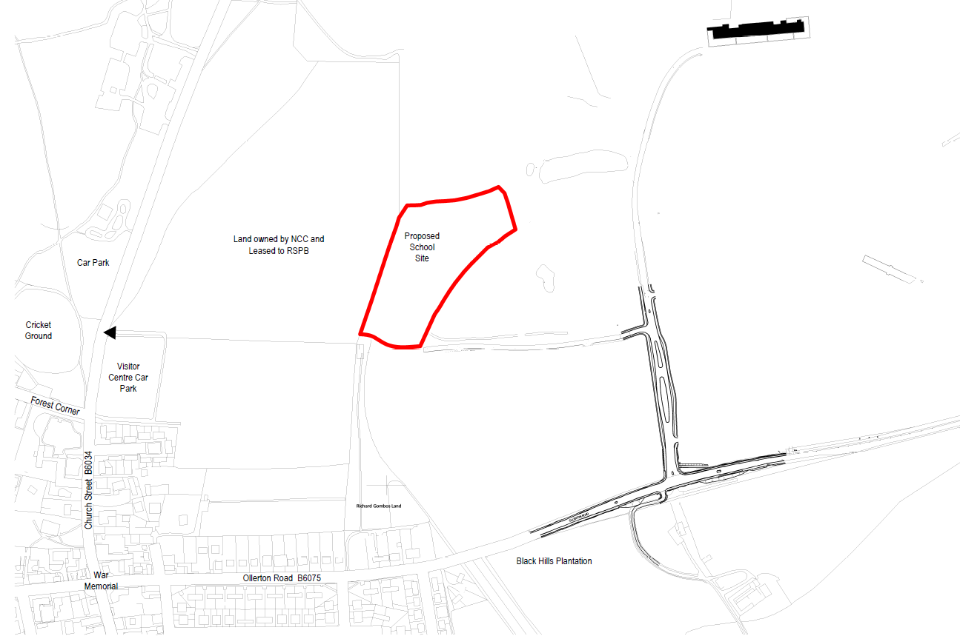

Or

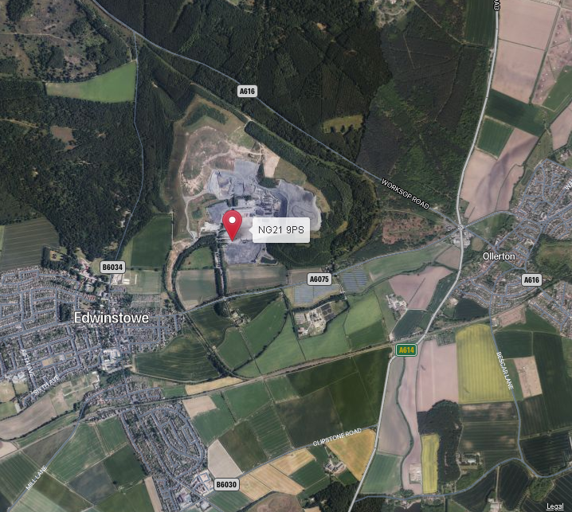

Housing Development at Thoresby Vale

It is projected that the 800 dwellings proposed for the Thoresby Vale site are likely to yield 168 primary-aged pupils who will require school places in the local area.

The relevant planning authority, Newark and Sherwood District Council, have provided a trajectory of house building for the first five years of this development, which is shown in table 1, below:

Table 1 | Year of completion
 | 2020-21 | 2021-22 | 2022-23 | 2023-24 | 2024-25
Projected no. houses completed | 13 | 30 | 35 | 35 | 30
Projected primary school places required per year | 3 | 6 | 7 | 7 | 6
Projected primary school places required - cumulative | 3 | 9 | 16 | 24 | 30

Newark and Sherwood District Council have also indicated that the construction of development will then continue for a further eight years, as follows:

Table 2 | Year of completion
 | 2025-26 | 2026-27 | 2027-28 | 2028-29 | 2029-30 | 2030-31 | 2031-32 | 2032-33
Projected no. houses completed | 85 | 85 | 85 | 85 | 85 | 85 | 77 | 70
Projected primary school places required per year | 18 | 18 | 18 | 18 | 18 | 18 | 16 | 15
Projected primary school places required - cumulative | 48 | 66 | 84 | 101 | 119 | 137 | 153 | 168

However, the Thoresby Vale developers have advised that construction is progressing more quickly than is indicated above, and it is probable that this faster rate will continue. As a result, additional school places will be required in Edwinstowe at an earlier date than suggested by the current trajectory.

Primary Schools in the Edwinstowe Planning Area

The map below shows the position of the 3 existing primary schools in the Edwinstowe Planning Area and the location of the Thoresby Vale housing development.

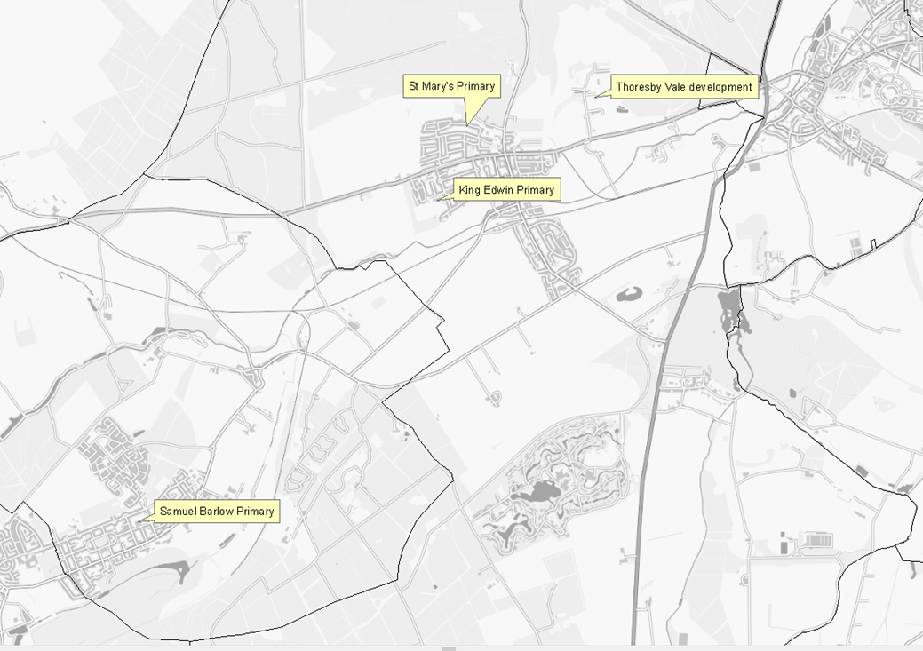

Table 2 Edwinstowe primary schools – capacity and number of pupils on roll

School | PAN* | Net Capacity** | Number on roll (NoR)  Sept. 2021 | Forecast NoR  Sept. 2023***
St Mary’s C.of E. V.A. Primary | 15 | 105 | 99 | 96
King Edwin Primary School | 60 | 420 | 389 | 430
Samuel Barlow Primary Academy | 40 | 231 | 252 | 307
*Published Admission Number (PAN): this is the number of places made available each year to applicants
**This is the number of places that a school’s building can reasonably accommodate
*** These figures do not reflect the advice of the Thoresby Vale developers regarding the faster than anticipated construction of new dwellings, as referred to on page 2 of this document

New Primary School on the Thoresby Vale Development

As part of the Section 106 agreement for the development of the Thoresby Vale site, developers are committed to deliver supporting infrastructure to the area. The developer has agreed to the allocation of a site of 2.58 hectares for the building of a new primary school for children aged 5 to 11.

This is a large development where a new school was a condition for the granting of the planning permission.

The new school would be built in accordance with the specifications described by the Department for Education (Building Bulletin 103) and under consultation with Nottinghamshire County Council.

Admission arrangements, which may include a catchment area for the new primary free school, would be decided by the sponsoring Multi Academy Trust. The trust that will operate the school will be selected through the Free School Presumption process.

The consultation process and Indicative timeline for opening a new primary free school

As per the timeline published below, this consultation will run for 6 weeks from:

Thursday 2nd December 2021 until Friday January 14th 2022.

Nottinghamshire County Council (NCC) will welcome responses to the consultation during this period.

The outcome of this initial consultation will be reported to Elected Members of the Children and Young People Committee, who will decide whether to proceed with a Free School Presumption process. If this option is chosen, NCC would invite Multi-Academy Trusts to apply during Spring term 2022 for selection to operate the new primary school, if that is the local authority’s decision.

Once proposals are received and have been evaluated, NCC will recommend a sponsor to the Regional Schools Commissioner who will make the final decision. NCC will then work with the successful sponsor and the housing developer to open the new school in September 2023.

Consultation Response Form

INFORMAL CONSULTATION ON LAUNCH OF A FREE SCHOOL PRESUMPTION COMPETITION

LOCAL AUTHORITY CONSULTATION REGARDING A NEW PRIMARY SCHOOL IN
THE EDWINSTOWE PLANNING AREA

If you wish to respond to the consultation you can share your views by:

- Completing the online survey on Nottinghamshire County Council’s consultation hub https://consult.nottinghamshire.gov.uk
- Emailing Nottinghamshire County Council at place.planning@nottscc.gov.uk
- Requesting a paper copy of this consultation from:
Pupil Place Planning, Education Learning and Skills, Children and Families Services, Nottinghamshire County Council, County Hall, West Bridgford, Nottinghamshire, NG2 7QP - to which your response should be returned.
…………………..……………………………………………………………………………………………….

Question 1.
Do you think that a new primary school with 210 places should be built on the Thoresby Vale development?
Yes
No
Neither agree or disagree

Question 2
Do you think that a new school should open on the Thoresby Vale development in September 2023?

Yes
No
Neither agree or disagree

Question 3
Do you have any further comments?

It will help us to analyse responses if we know more about you.
Please complete the following details:
(Please tick and complete all boxes that apply)
I am a:

Parent / Carer | Which school / academy do(es) your child(ren) attend?
Governor | At which school / academy?
Member of Staff | At which school / academy?
Pupil | At which school / academy?
Other | Please specify (e.g. resident)
What is your post code?

Responses should be returned to:

- Nottinghamshire County Council at place.planning@nottscc.gov.uk or
- Pupil Place Planning, Education Learning and Skills, Children and Families Services, Nottinghamshire County Council, County Hall, West Bridgford, Nottinghamshire, NG2 7QP

by 23:59hrs on Friday 14th January 2022

