Bus Stop Clearway – Tuxford Road, East Markham
(BA0523)
No stopping 7am – 7pm Mon - Sat, except buses.

The County Council is to install a new bus stop clearway marking and sign on Tuxford Road near its junction with Mark Lane and Priestgate. The clearway would prohibit stopping by all vehicles, except buses and would be in force 7am to 7pm Monday to Saturday. The location of the new marking is shown on the drawing below.

The clearway will help to ensure that the bus has unobstructed access to the raised kerbs allowing wheelchair users, the elderly and parents with pushchairs, level access onto and off the bus. A correctly aligned bus will not block the road for other road users and will help ease congestion.
While the new bus stop clearway is being installed the school keep clear marking will also be relined.
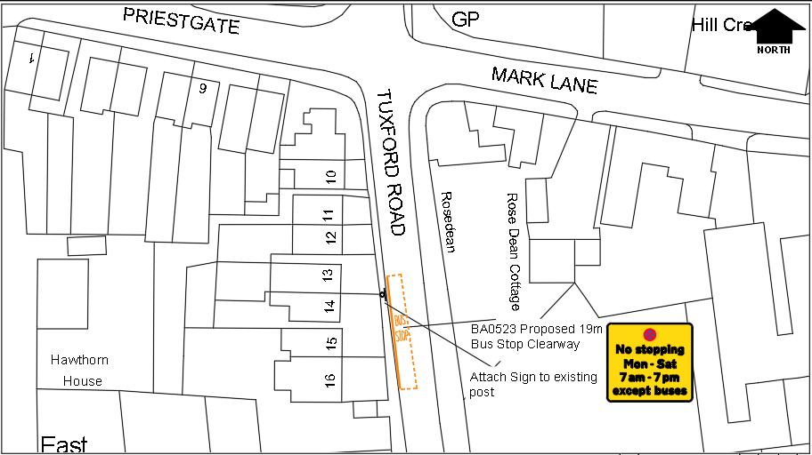

Any comments on the new restriction must be received in writing by 14th May 2018.

Improvements Manager
Via East Midlands Ltd
County Hall
West Bridgford
Nottingham
NG2 7QP

tmconsultation@viaem.co.uk

